Walking Home in Berlin, 1912:
a geographic expedition through an historical public space
Bob Sharpe, November 1, 2011

Objectives
- To demonstrate how walking can be a research method that leads to discoveries of human geographical knowledge
- To demonstrate, in material terms, that human geographical knowledge is contextual, partial, situated and embodied. The lens through which we will explore the historical public spaces and places of Berlin in 1912 is through that of the guided walking tour. Walking, as a methodology, is a profoundly behavioural approach: through our own walking we will examine the discoveries of the researcher who, on foot, has investigated the pedestrian activities of previous residents of this place
- To lay claim to an historical public places (and escape the confines of the classroom)
- To understand that the adaptive reuse of spaces is not limited to buildings but includes the adaptive reuse of pedestrian space

103 Joseph St., 6 and 8 Richmond Ave.
Kitchener, Ontario, 2011

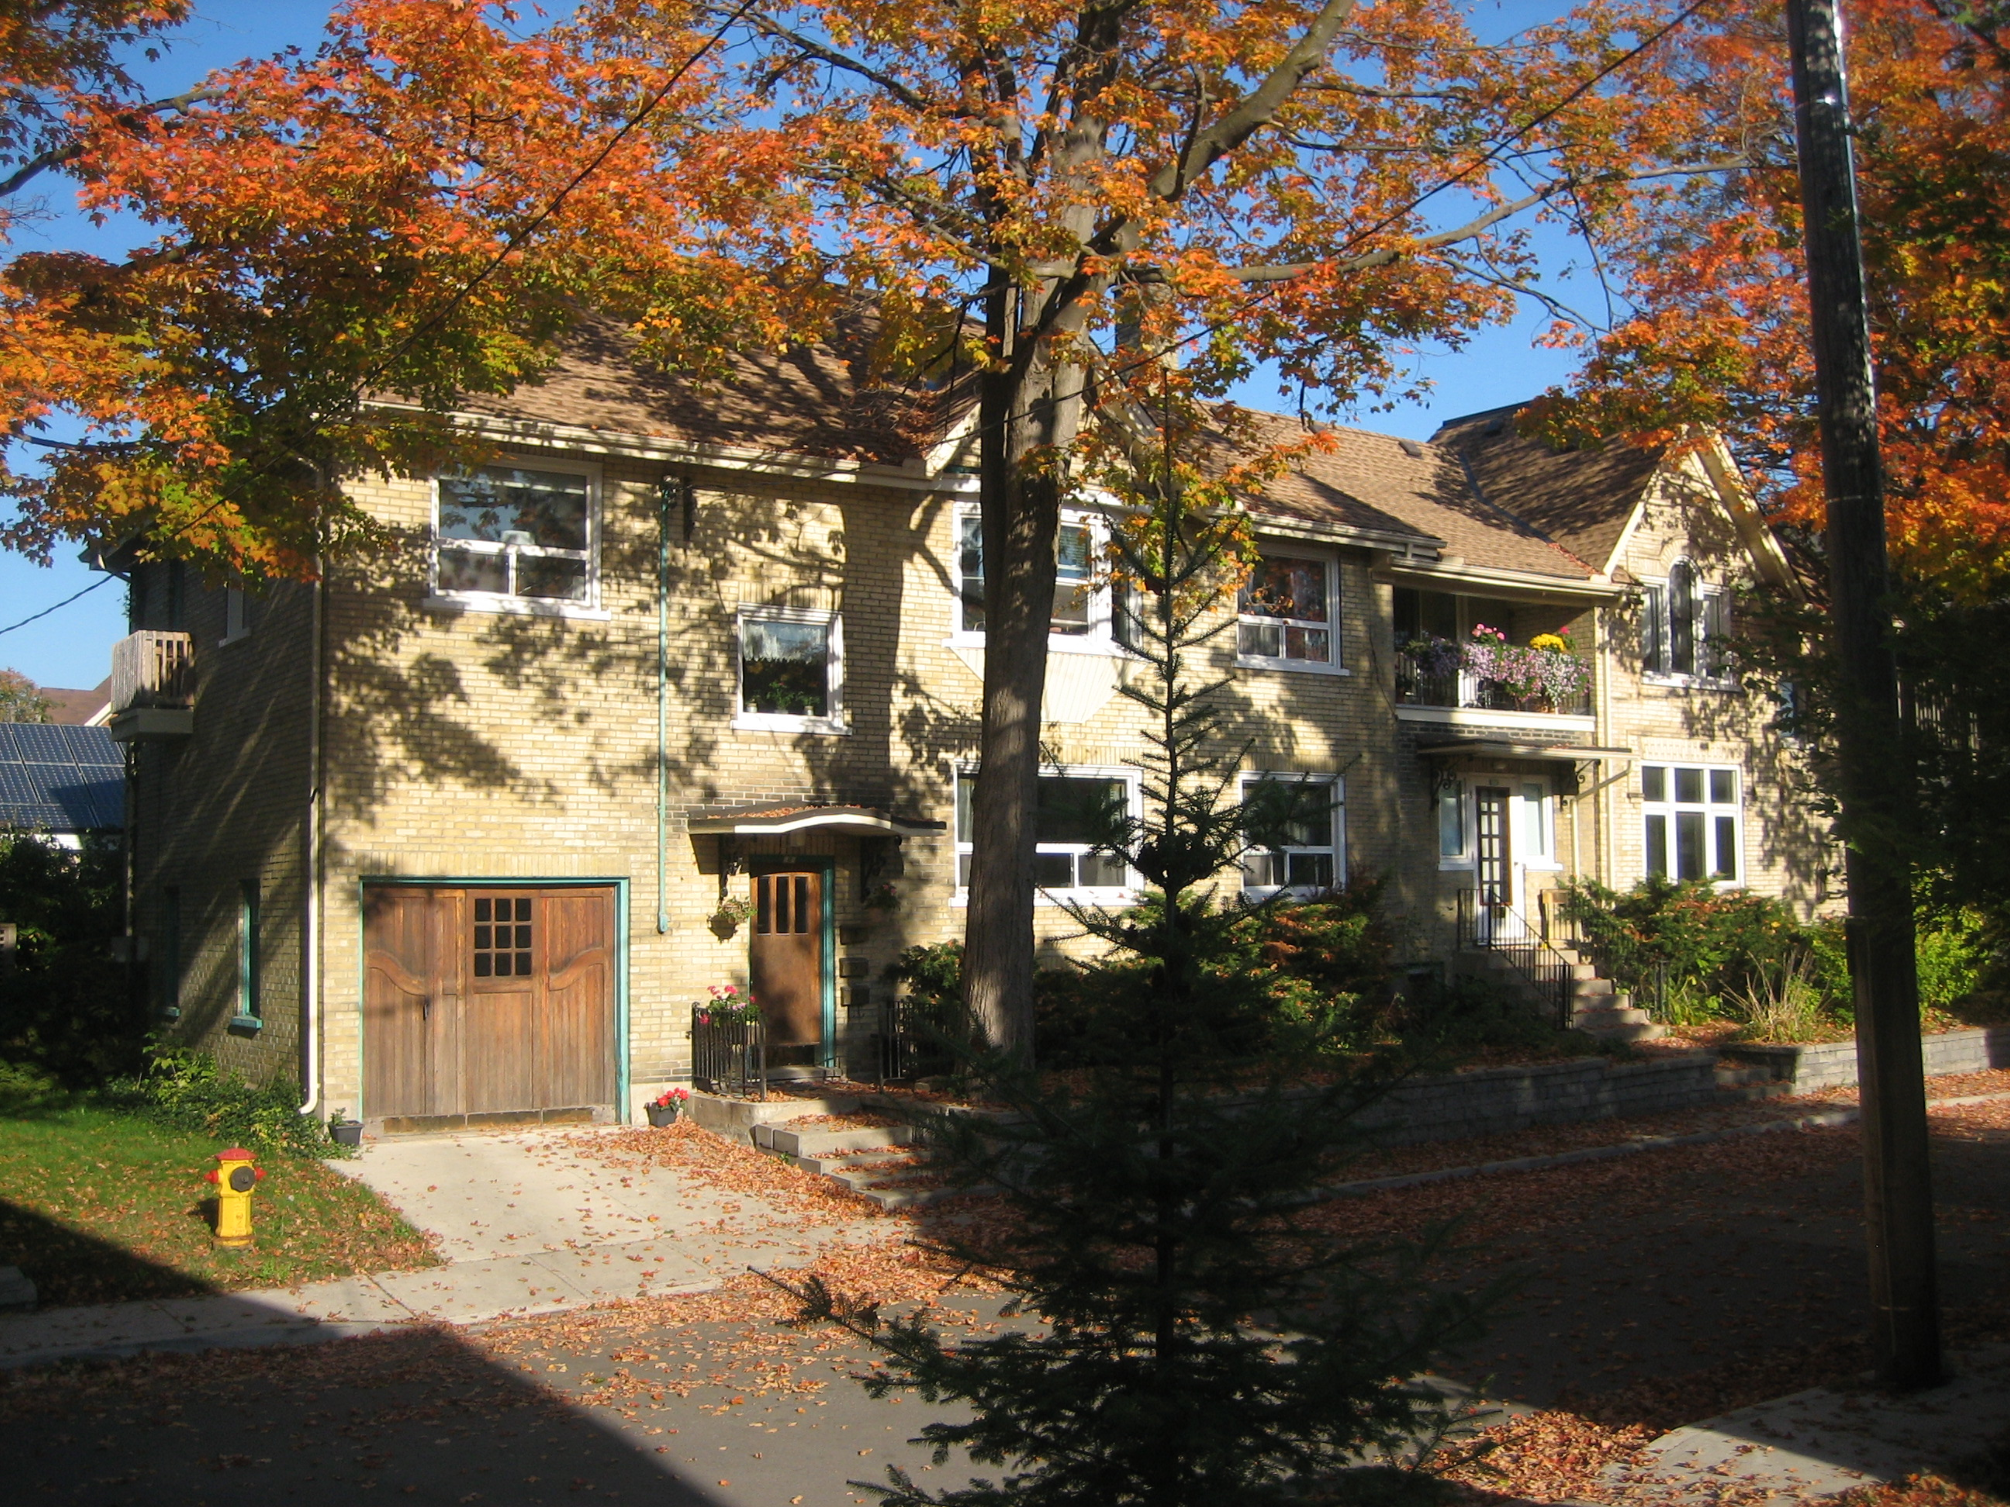

Timeline of property transactions related to
103 Joseph St. Kitchener, Ontario, 2011

Sources: initially, the main source of data is the Land Registry Record, (Abstract Microfilm 58E5); supplemented with details from other sources including original plans of subdivision, municipal maps, voters lists, and Vernon’s directory, as noted below:

1798 Crown grants land to Richard Beasley for 8,888 pounds Sterling.
1815 Lot 16, German Company Tract (G.C.T.) purchased by Henry? Weaver
1853-54 Lot 16 becomes part of the Amended George Grange’s Survey, Plan 378, Park Lot 552
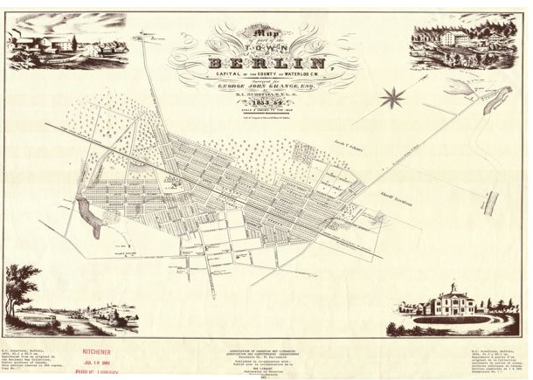
George Grange’s Survey, 1853-1854, KPL

1877 Edward J. Seip born on a farm outside of St. Agatha
1879 Mary Seip (nee Becker) born in Berlin, Ontario

1887 Voter’s list for Town of Berlin, 1887 (1,408 votes), and 1888 (1,624 votes), Rare Book Room, Dana Porter Library
- 1887: George Proudfoot, roll #450, Lots 167-169, Grange’s Survey
- 1888: George Proudfoot, Lots 165-169, Maynard Street

1893 John A. Mackie, owner of part of Park Lot 552, (from the German Company Tract, 1815 in the amended George Grange’s Survey, Plan 378);
J.A. Mackie sells 3 acres to George and Elizabeth Proudfoot

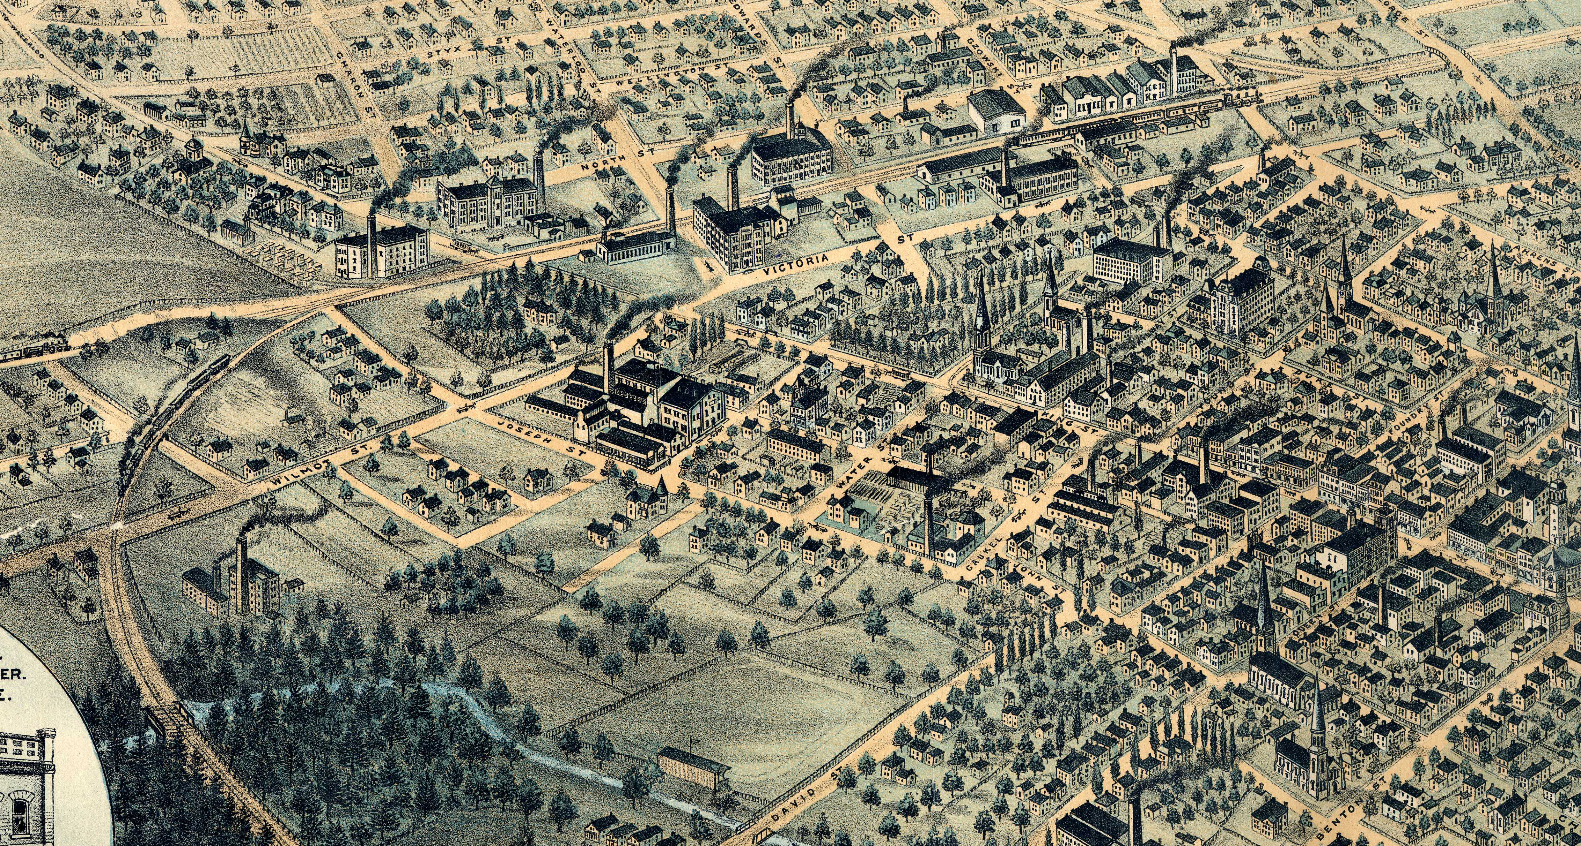
Berlin, 1892-96: M907 map portion 1896 – GSR, KPL

1895 The date recorded for the construction of 103 Joseph St is 1895
George Proudfoot dies in 1894; Elizabeth stays until here death in 1903

1904 Plan 80, Richmond St. is registered to Catharina Heiman and John Schwartz;
Catharina & Frank Heiman and John Schwartz sell Lot 10 to Albert Hannenberg (possibly a land developer)

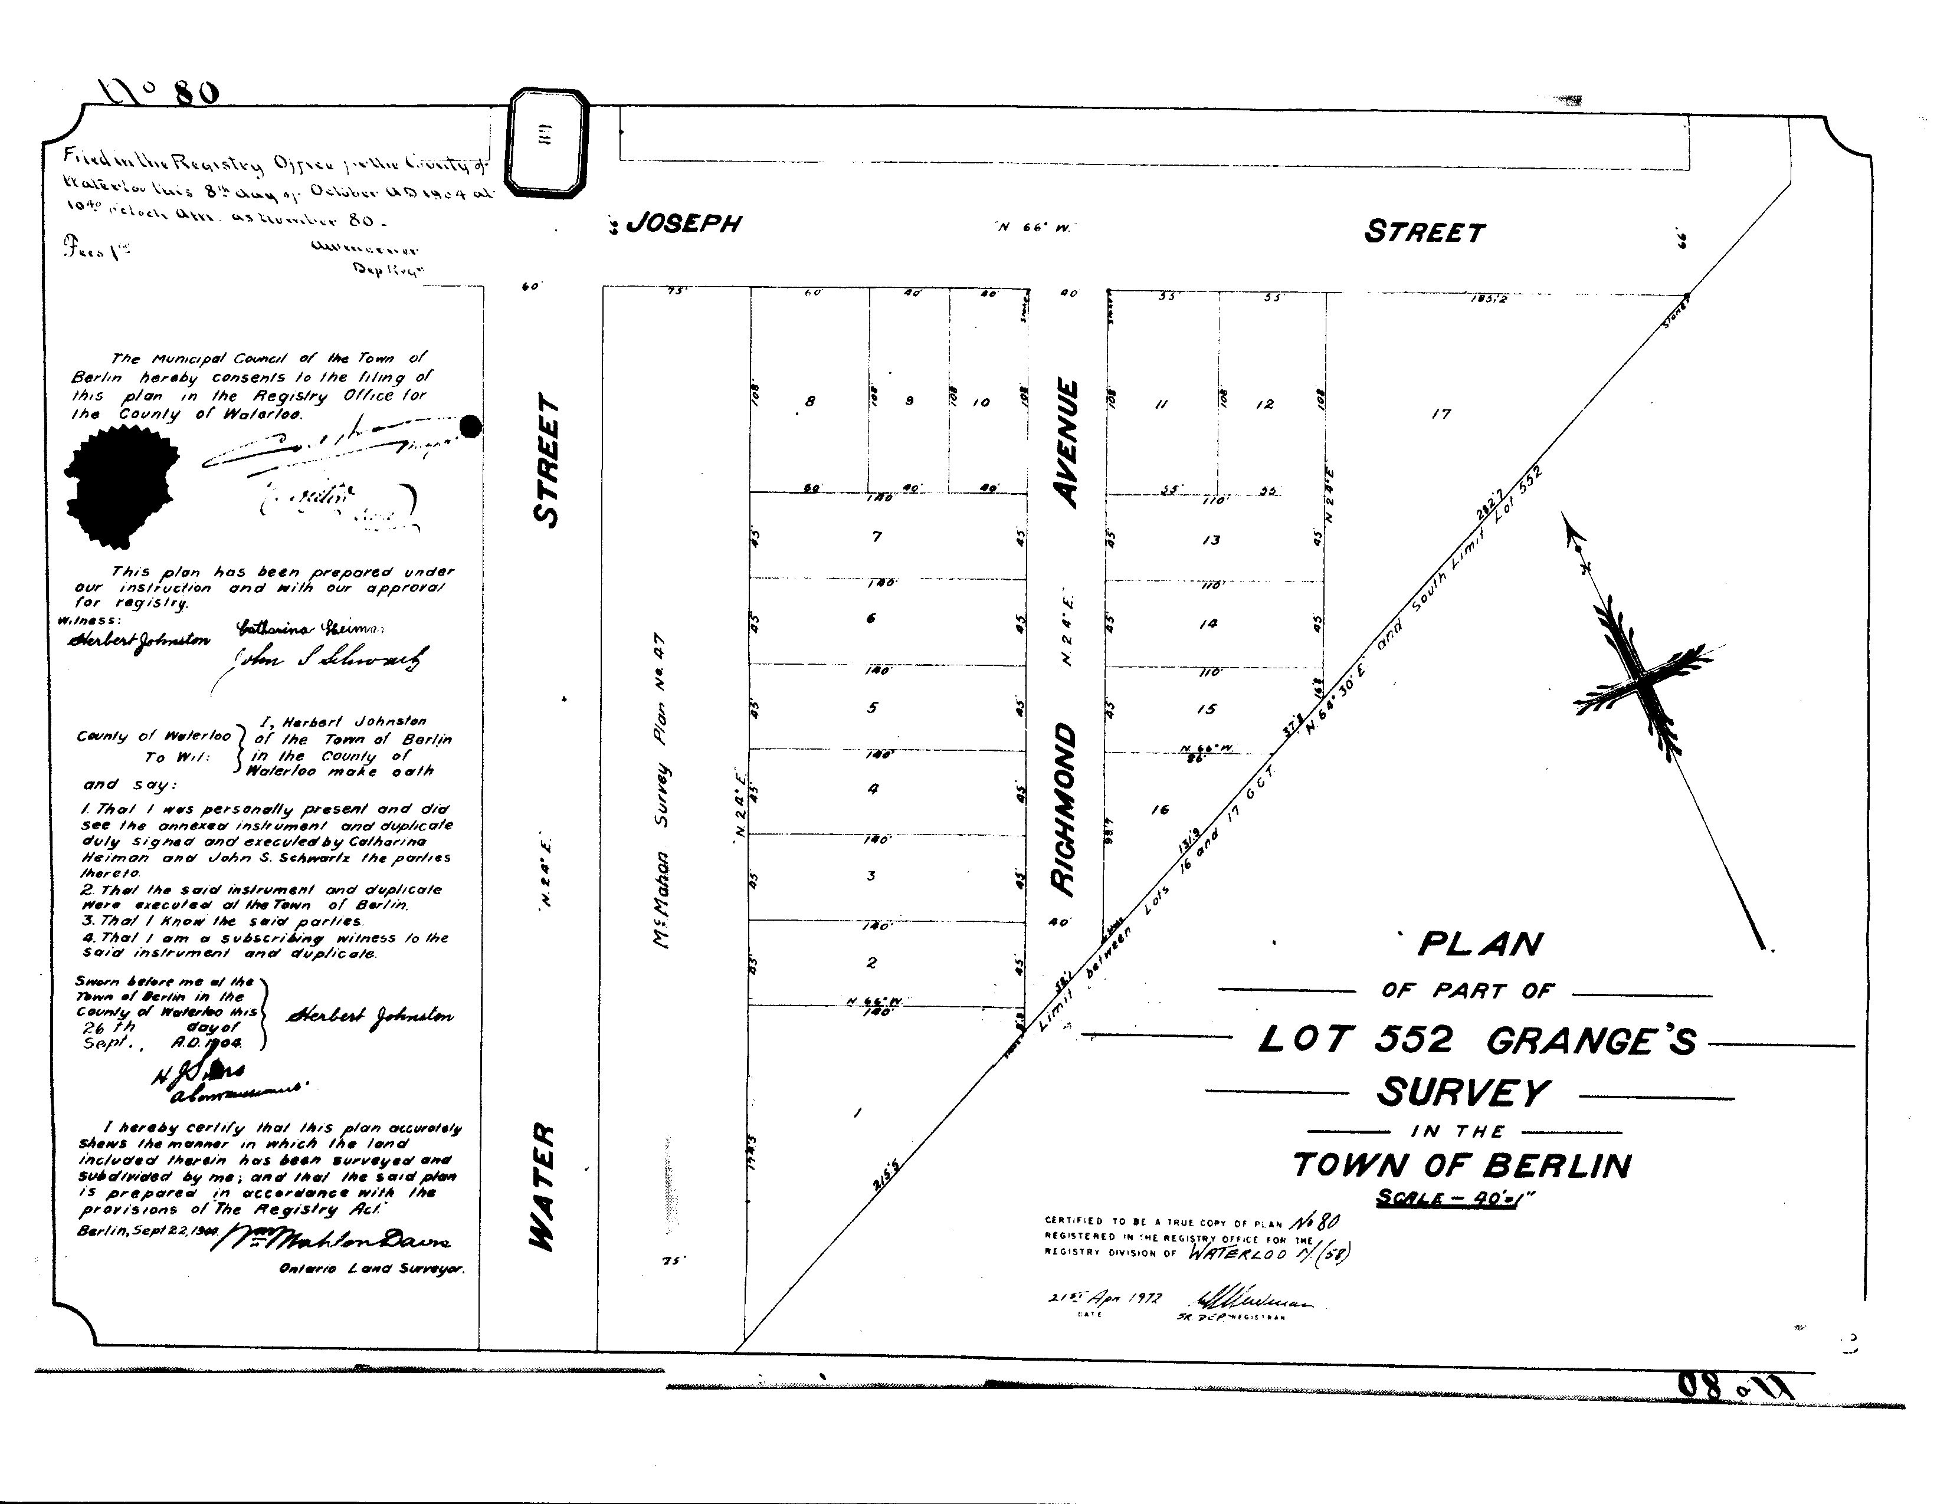
Plan 80, Lot 552, Grange’s Amended Survey, Land Registry Office, Duke St. Kitchener

1906 Albert Hannenberg sells Lot 10 to Edward J. Seip
1907-08 E. J. Seip works at the Pearl Laundry
1912-13 E. J. Seip works at Hagen Shirt and Collar, renamed J.A. Lang Shirt and Collar Co.
1918 E. J. Seip works as an ironer at J.A. Lang Shirt
1930 E. J. Seip works as a mechanic at Miller-Lang Shirt
1931 E. J. Seip listed with no occupation, Seip Apartments open at 6 and 8 Richmond
1932 103^{½} Joseph records first tenant in Vernon’s Directory
1935 E. J. Seip, caretaker, Seip Apartments
1943 Edward J. Seip dies at age 67 and is buried at Mt. Hope Cemetery
1960 Mary Seip dies at 81 and is buried with E.J.;
Lot 10 is granted to Thomas & Doris Gitschner

From 1930 – 1960 the Seip apartments were home to over fifty tenants. They included employees at local retail stores, foremen at butchers and at a rubber plant, nurses, widows, and retirees.

